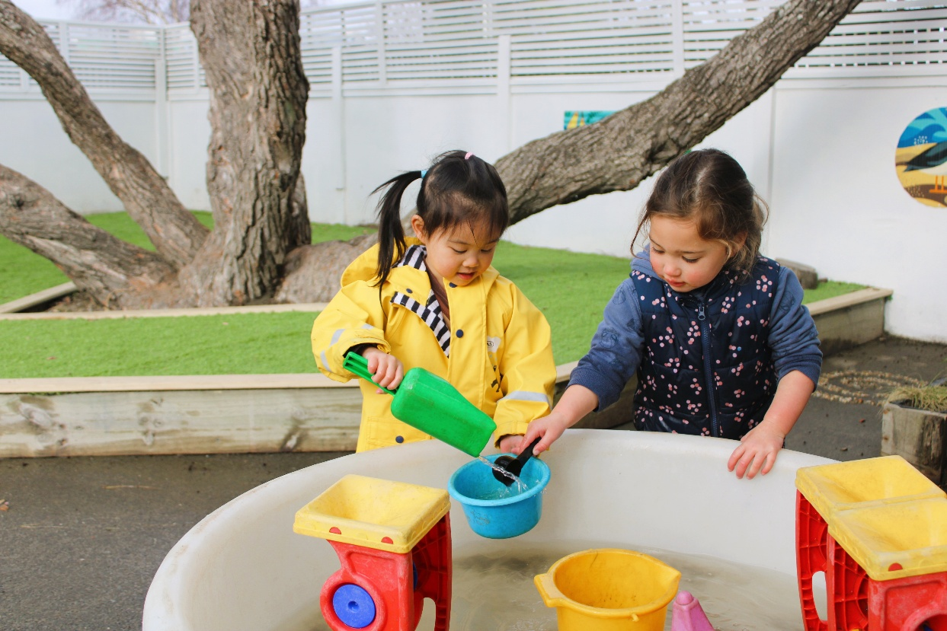
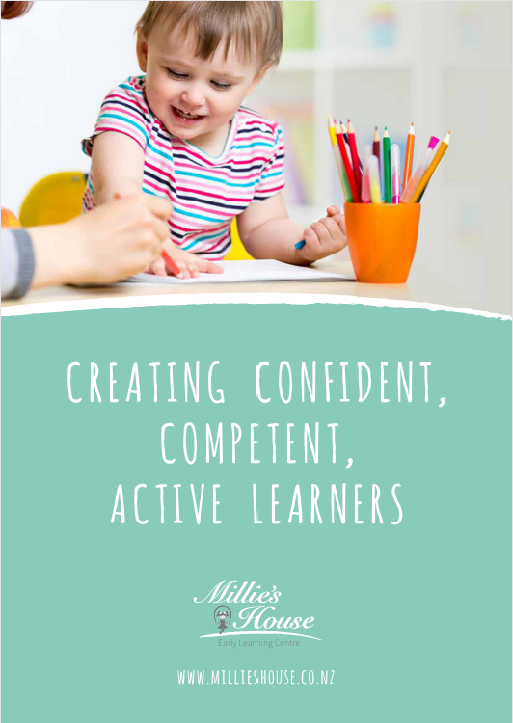

Learning together,
hand in hand

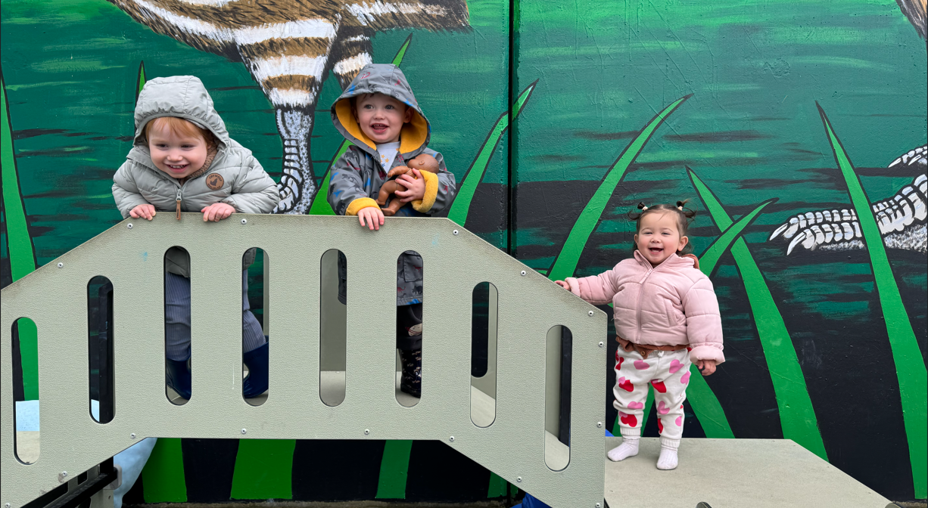
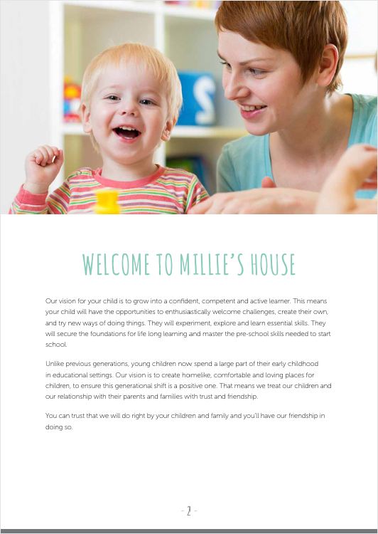
Our vision for your child is to grow into a confident, competent and active learner. This means your child will have the opportunities to enthusiastically welcome challenges, create their own, and try new ways of doing things. They will experiment, explore and learn essential skills. They will secure the foundations for life long learning and master the pre-school skills needed for a successful start at school.
Unlike previous generations, young children now spend a large part of their early childhood in educational settings. Our vision is to create homelike, comfortable and loving places for children, to ensure this generational shift is a positive one. That means we treat our children and our relationship with their parents and families with trust and friendship.
You can trust that we will do right by your children and family and you’ll have our friendship in doing so.

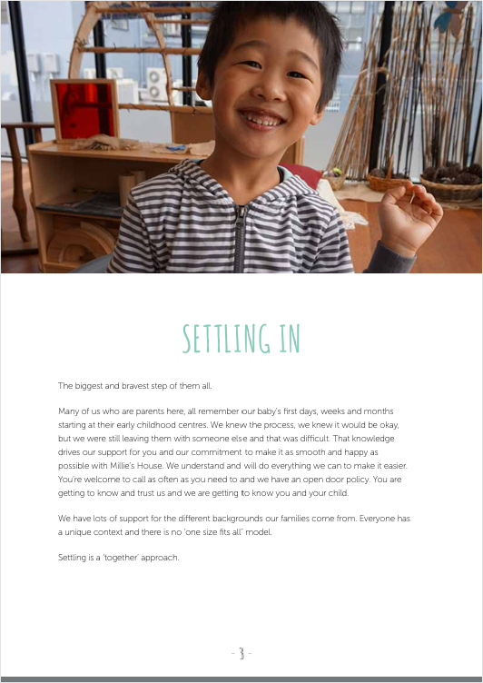
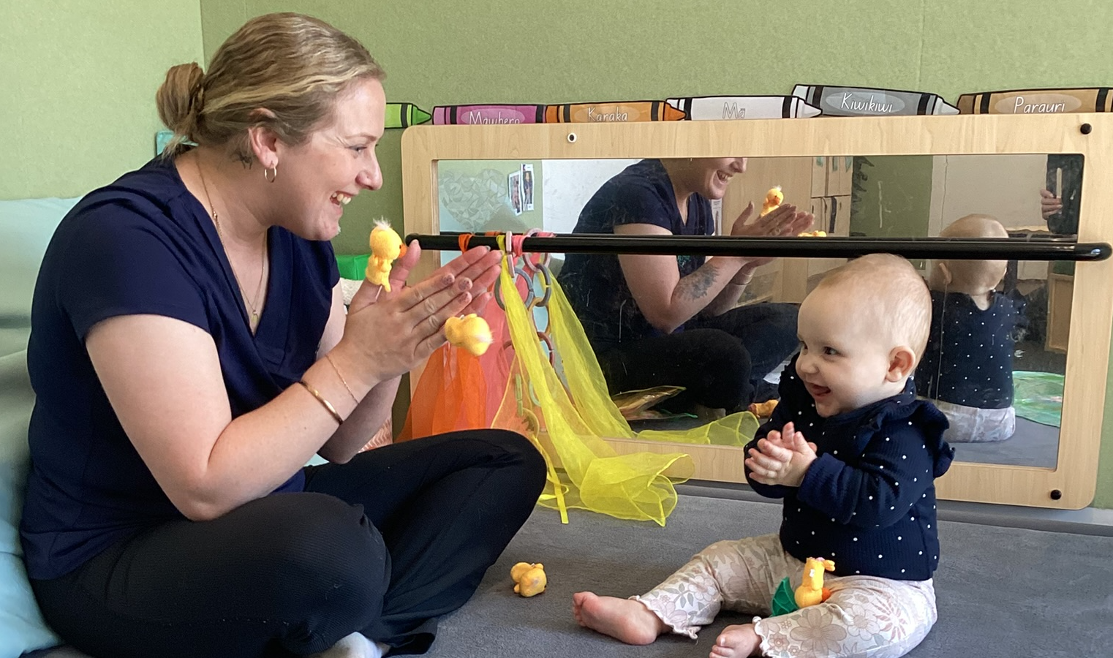
The biggest and bravest step of them all. Many of us who are parents here, remember our baby’s first days, weeks and months starting at their early childhood centres. We knew the process, we knew it would be okay, but we were still leaving them with someone else and that was difficult. That knowledge drives our support for you and our commitment to make it as smooth and happy as possible with Millie’s House. We understand and will do everything we can to make it easier. You’re welcome to call us as often as you need to or drop in and spend some time with us.
You are getting to know and trust us, and we are getting to know you and your child. We have lots of support for the different backgrounds our families come from. Everyone has a unique context and there is no ‘one size fits all’ model. Settling is a ‘together’ approach

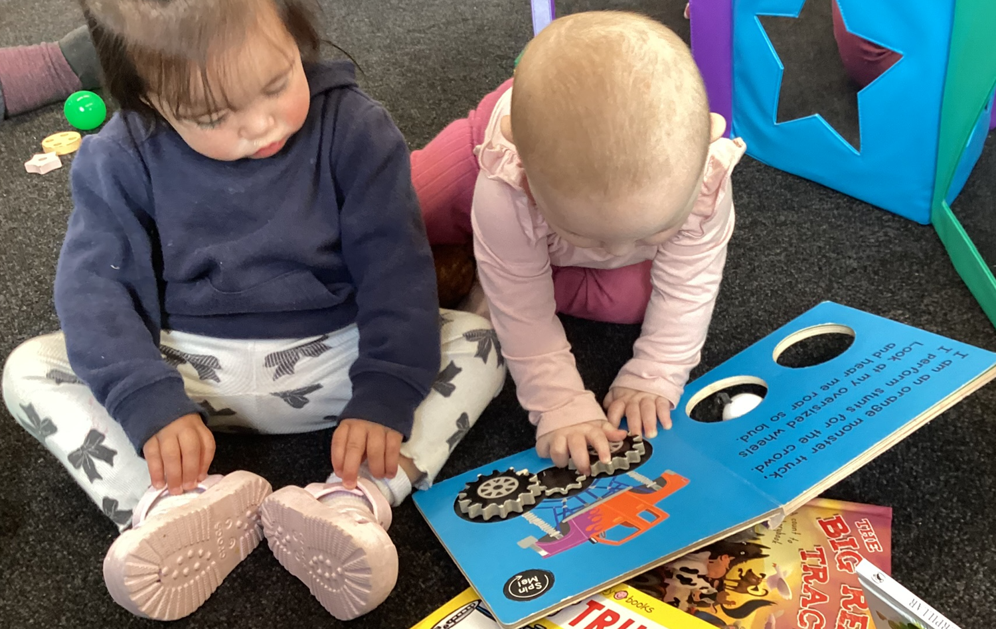
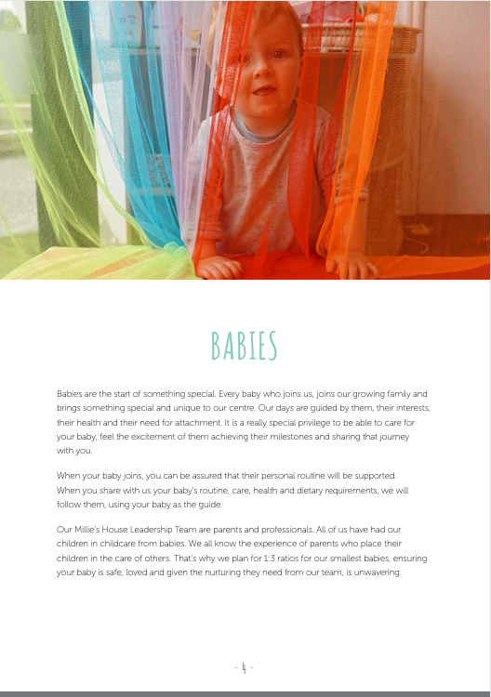
Babies are the start of something special. Every baby who joins us, joins our growing family and brings something special and unique to our centre. Our days are guided by them, their interests, their health and their need for attachment. It is an incredibly special privilege to be able to care for your baby, feel the excitement of them achieving their milestones and sharing in their journey with you.
When your baby joins, you can be assured that their personal routine will be supported. When you share with us your baby’s routine, care, health and dietary requirements, we will follow them, using your baby as the guide.
Our Millie’s House Leadership Team are parents and professionals. Most of us have had our children in childcare from young babies. We all know the experience of parents who place their children in the care of others. We will ensure your baby is safe, loved and given the nurturing they need from our team to safely grow and learn.

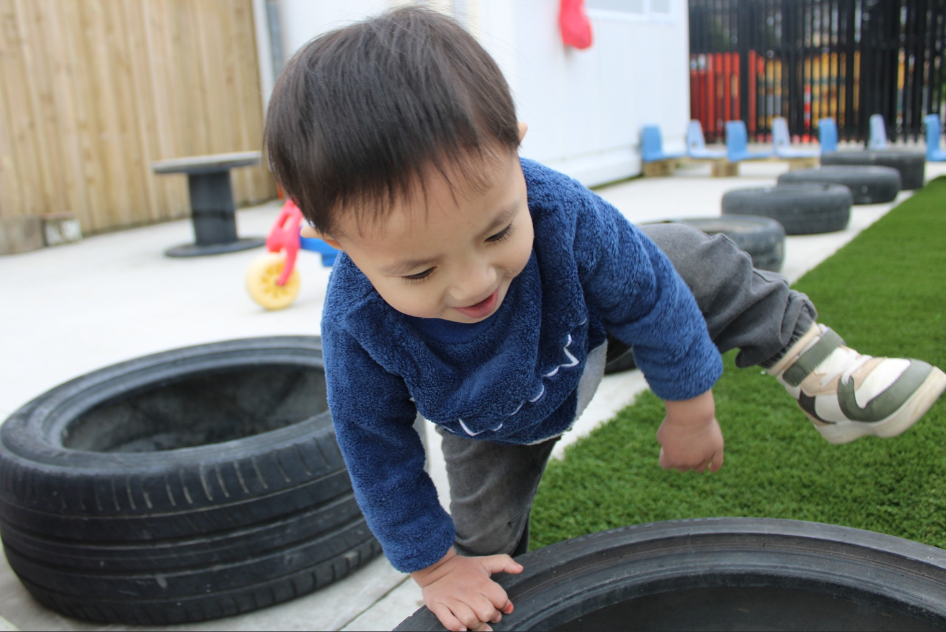
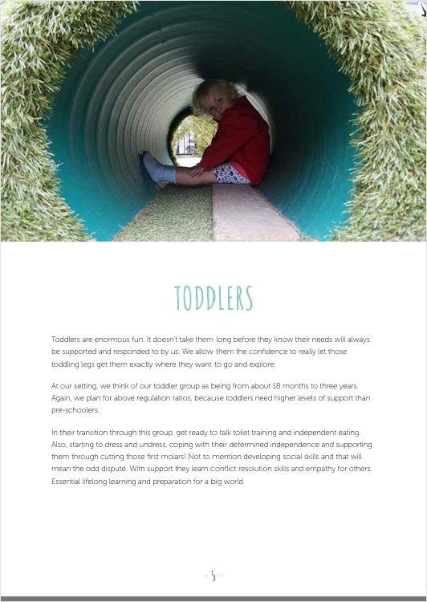

At our settings, we think of our toddler group as being from about 18 months to three years.
Toddlers are great fun and this is an active, curious, fast paced and often quite messy stage.
Toddlers can finally move themselves to where they want to be, to investigate what they want to investigate! They keep us on our toes because they are learning the outcome of risk as they push the boundaries of safety and often each other.
In their transition through this group, we will talk toilet training, independent eating, starting to dress and undress, coping with their determined independence and navigating developing social skills.

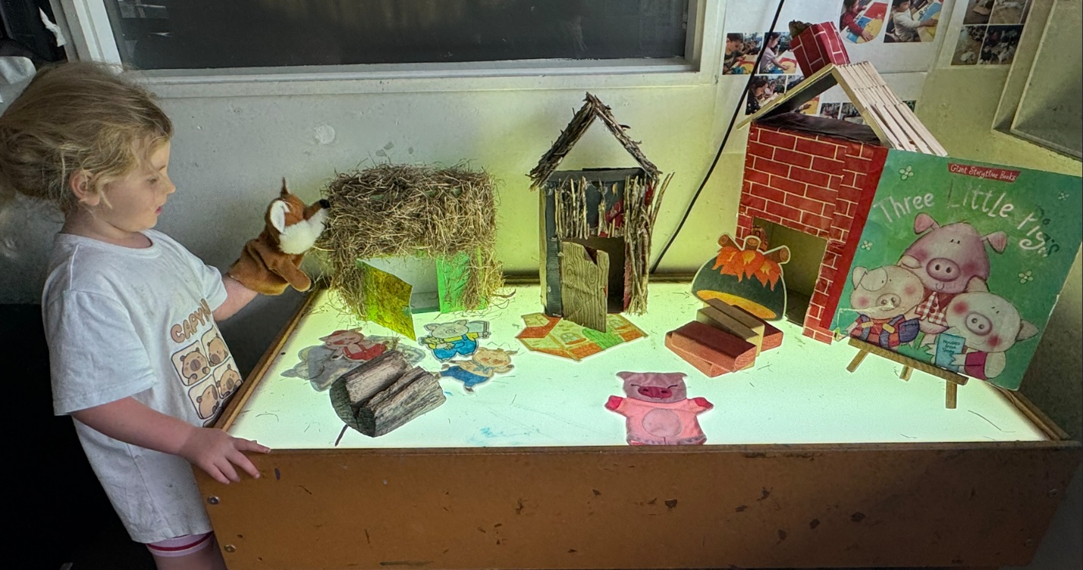
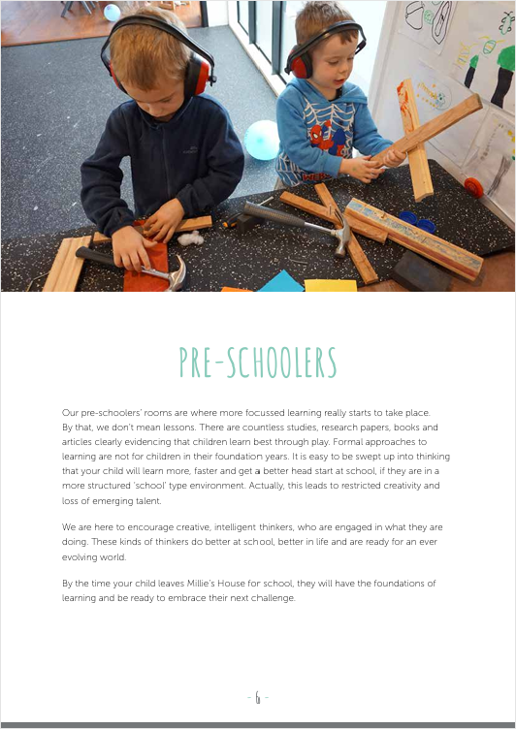
Our pre-schoolers’ rooms are where independence, social competence and school readiness is focused. We want children to be able to look after themselves, their belongings and each other.
Our preschool teachers intentionally support numeracy and literacy, science, social competence, physical development and the arts, through a variety of experiences where exploration, enquiry, creativity, critical thinking and problem solving through play is valued.
We are here to encourage creative, intelligent thinkers, who are engaged in what they are doing. These kinds of thinkers thrive at school, do better in life and are ready for an ever-evolving world.
By the time your child leaves Millie’s House for school, they will have the foundations of learning and be ready to embrace their next challenge of school.

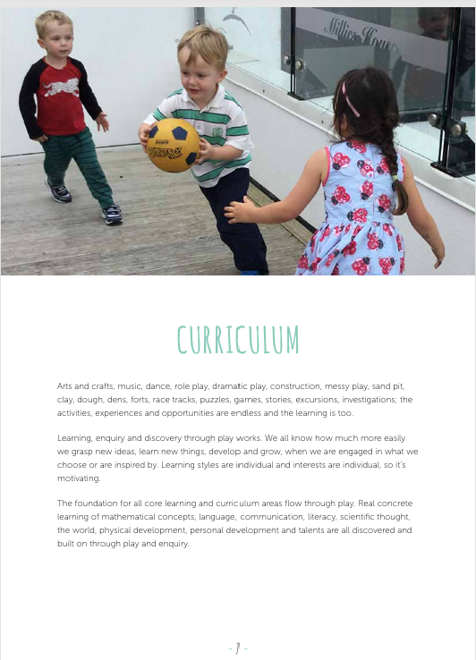
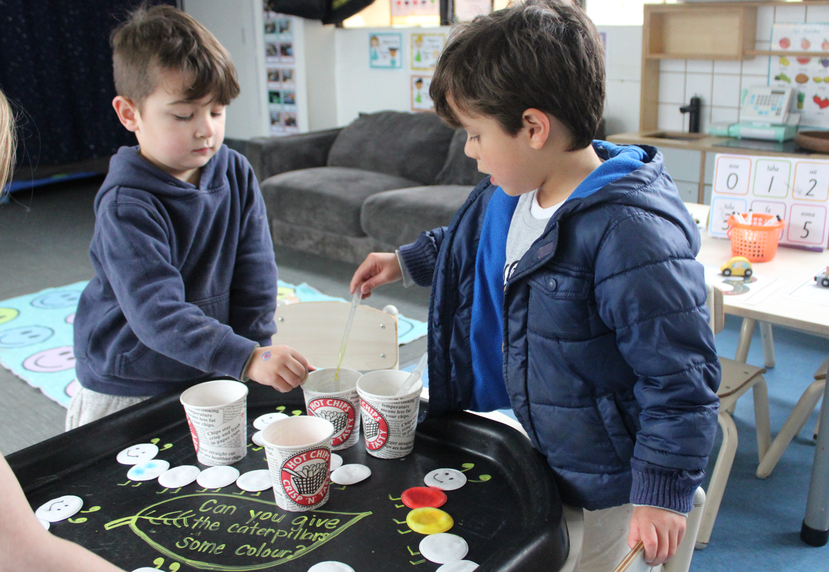
Enquiry, problem solving, critical thinking and discovery through exploration and play is how new ideas, concepts, knowledge and understanding develops and grows. When children are engaged in what they are interested in or are inspired by, they pick up mathematical concepts, numbers, reading, writing, science, facts, skills and abilities more easily and retain that learning.
Our curriculum planning, implementation and evaluation cycle is planned for termly, alongside school terms for all age groups. We plan for each individual child from parents’ aspirations for their learning, their strengths, challenges and needs, how we know them and what they are interested in. Each term we assess their towards the twenty learning outcomes of Te Whāriki, our New Zealand ECE curriculum.
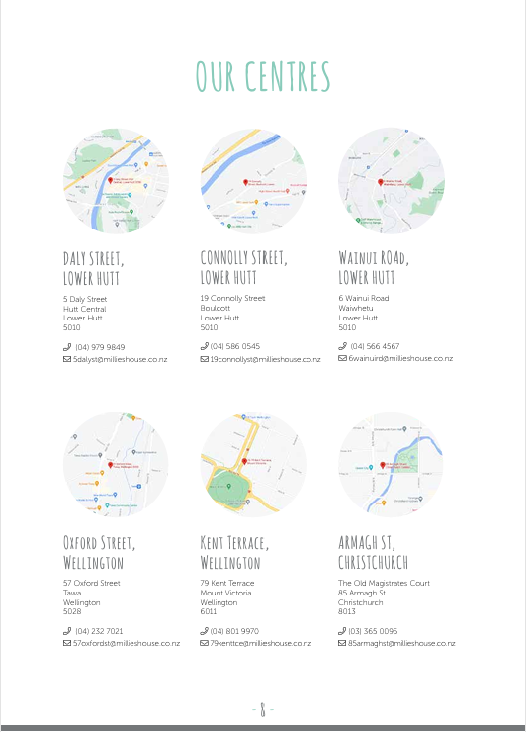
Shirley and Hopper to be added in
